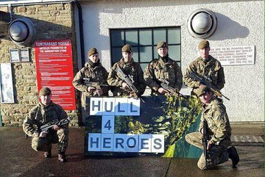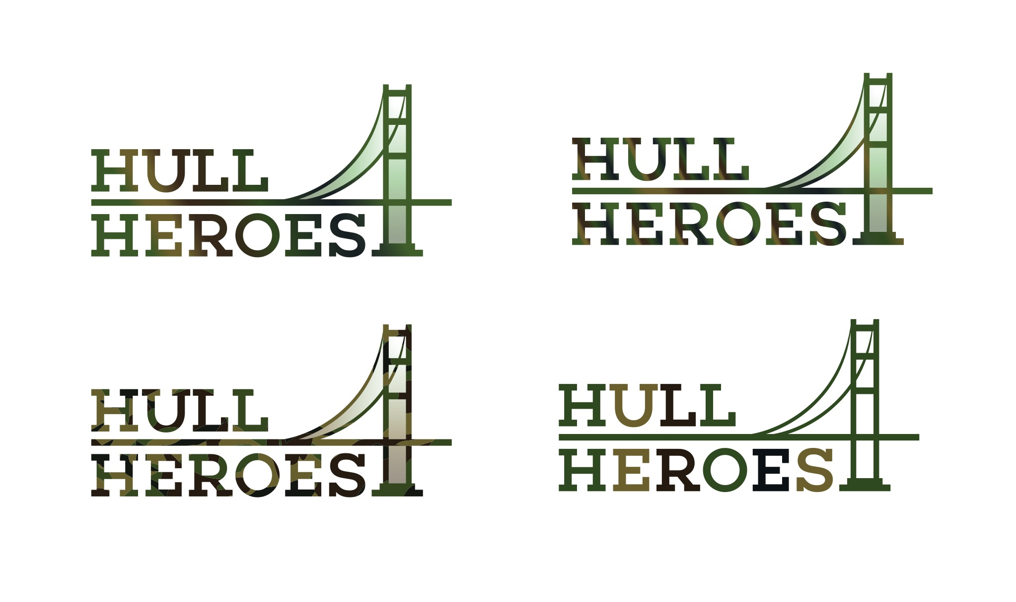

CHARITY NIGHT

CALLING ALL MEMBERS, PARTNERS AND FRIENDS

COTTINGHAM PARKS GOLF & LEISURE CLUB

HELP OUR
HULL 4 HEROS

SATURDAY 21ST OCTOBER 2017 - 7.30 P.M

TICKETS £10

PIE AND PEA SUPPER

DISCO
LIVE ENTERTAINMENT WITH
PAUL WHITE AND GUEST ARTIST CLAIRE

AUCTION AND RAFFLE

MAIN AUCTION ATTRACTION

(Donated by Diplomatic Mission Supplies)

TWO GOLD CLUB WEMBLEY SEATS FOR THE 2017/18 LEAGUE CUP FINAL INCLUDES: Champagne Reception followed by a three course meal with free flowing wine/beer or soft drinks.

PROCEEDS TO THE HULL 4 HEROS
CHARITY NUMBER 1170056

FOR TICKETS PLEASE CONTACT

Sharon Helm: 07999929764
Sue Taylor: 07885206402

